*Florida International University*

*School of Computing and Information Sciences*

Software Engineering Focus

Feature Document

User Story ID # 333

**Name:** Show Pending Documents on Supervisor’s Log.

**Team Member(s):** Darilys Pereira

**Project:** Virtual Roll Call 4.0

**Product Owner(s)**: Jason Cohen

**Mentor(s)**: Juan Caraballo

**Instructor**: Masoud Sadjadi

**User Story Name:** Show Pending Documents on Supervisor’s Log.

* Description: **As a** supervisor, **I would like** that pending documents are displayed in my log **so that I can** keep track of who has not reviewed certain documents and have more accurate reporting.

Acceptance Criteria

* Display pending documents in the supervisor’s log.
* Display should follow the same format as reviewed ad done documents that are currently displayed.

**Use Case**

* Name: Logs and Reports
* Actor: Supervisor
* Preconditions:

1. System is up and running
2. User has successfully logged into the system.
3. Connection to the database has been established.

* Description:

1. Supervisor clicks on the Log side menu under the Supervisor section of the application.
2. Report is displayed including Done, Pending, and Reviewed document status.
3. Supervisor might adjust grid filters and export grid to csv or pdf.

**Use Case Diagram**

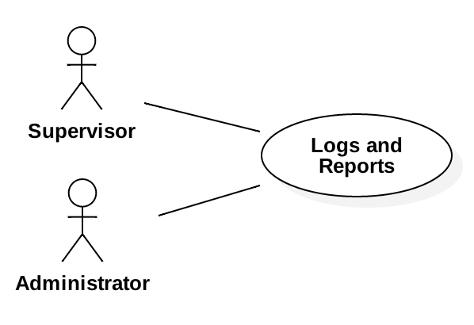

**Sequence Diagram**

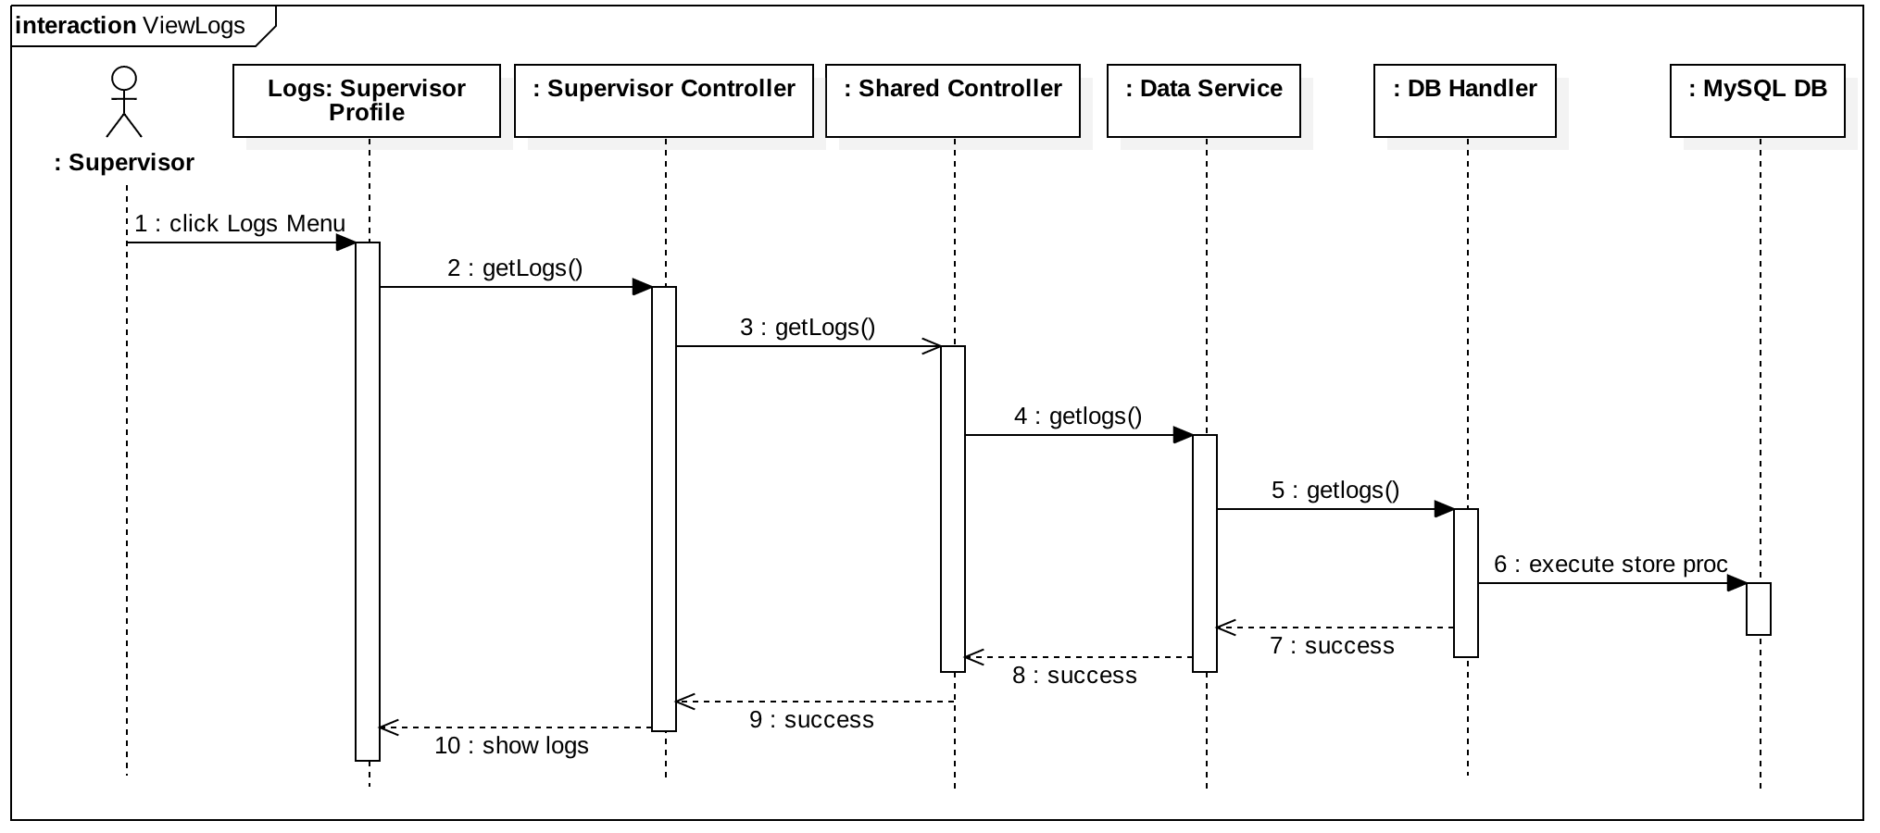

**Class Diagram**

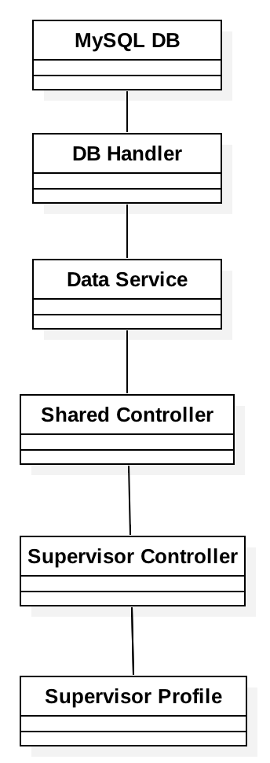

**Unit Test**

* Test case ID: User Story # 333 - Show logs
* Description/Summary of Test: Verify that log results include Done, Pending, and Reviewed status.
* Pre-condition:

1. User is logged into the system.
2. User is in Logs page under Supervisor menu.

* Expected Results: Report should return the list of all officers and the documents they have access to with their current status (Done, Reviewed, Pending)
* Actual Result: All rows were populated correctly for each officer displayed the corresponding document status.
* Status (Fail/Pass): Pass

**Integration Test**

Tested system by:

1. Uploading new documents to categories.
2. Logging into the system as different users and changing the document status.
3. Verified logs showed the correct metric based on user action and document status.

Status: Pass

**Visual User Guide**

